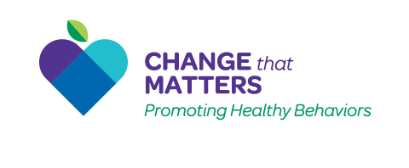

Implementation Toolkit

Development Team
Stephanie A. Hooker, PhD, MPH (co-PI)^{1,2}
Michelle D. Sherman, PhD, ABPP (co-PI)¹
Anne Doering, MD¹
Kacey Justesen, MD¹
Katie Loth, PhD, MPH, RD, LD¹
Jean Moon, PharmD, BCACP¹
Samantha Ngaw, MD¹
Andrew Slattengren, DO¹
Marc Uy, BA, MPH¹

¹University of Minnesota, Department of Family Medicine and Community Health
²HealthPartners Institute, Minneapolis, MN

Special thanks to our funders:
University of Minnesota Academic Health Center
and
University of Minnesota Herz Faculty Development Award
and
National Center for Integrated Behavioral Health

https://ChangeThatMatters.umn.edu/

June 2021
Rationale for the Development of Change that Matters
In the last century, chronic diseases, including heart disease, cancer, stroke, diabetes, and respiratory diseases, have risen above communicable diseases as the leading causes of mortality in the United States.¹ Managing and treating these chronic conditions put a large burden on the healthcare system. Indeed, 86% of healthcare spending goes to treating patients with one or more chronic condition.² With the growing burden of chronic disease, it may be surprising to learn that the majority of these diseases are largely preventable. Evidence suggests modifiable health behaviors, such as tobacco use, poor diet, physical inactivity, alcohol consumption, and substance use, are the top risk factors for lower disability-adjusted life years.³ Although most Americans know what behaviors are recommended for good health, many fail to regularly engage in these behaviors.⁴⁻⁷ For example, less than 10% of US adults meet the national guidelines for physical activity per week ⁸ and about 15% of adults smoke cigarettes.⁹ Fortunately, numerous brief interventions for these behaviors have been found effective in primary care settings,⁸ such as increased patient activity levels in patients who received physical activity prescriptions from their physicians,^{10,11} increased tobacco cessation and medication adherence among patients who received motivational interviewing-based interventions from physicians,^{9,12,13} and decreased alcohol consumption in primary care patients who received brief behavioral interventions.¹⁴
Primary care is an ideal setting in which to address these modifiable behaviors. The easy access to care, the continuity across time and stages of health/illness, and the comprehensive approach to health espoused by primary care physicians (PCPs) enhance the development of trusting, collaborative relationships.¹⁵ Given these ongoing PCP-patient relationships, it is possible that patients feel comfortable sharing struggles with making behavioral change with their PCPs, and may be more open to their recommendations than those from a specialist. Research in the domain of smoking cessation has found that patients whose PCPs ask about smoking or give advice about quitting report higher levels of satisfaction with their healthcare than if PCPs do not broach the topic.¹⁶ Importantly, numerous brief interventions for these behaviors have been found effective in primary care settings.^{8,17} Moreover, Healthy People 2010 called PCPs to action to assess and counsel their patients regarding physical activity, nutrition, and smoking to improve national health. Thus, effective encouragement of small changes in these health behaviors is a critical skill for PCPs.
However, research has found that PCPs do not generally spend a lot of time assessing healthy lifestyle practices or talking with their patients about health behaviors, even when clear practice recommendations exist. For example, the United States Preventive Services Task Force recommends that PCPs screen adults for alcohol misuse and provide brief behavioral counseling interventions to those engaging in risky use;¹⁸ however, in a large national survey of patients who had seen a PCP in the past year, only 25% reported that they had been screened for alcohol misuse.¹⁹ Beyond screening, data from the Veterans Health Administration show that PCPs spend an average of less than 1% of their face-to-face time with patients discussing preventive care, including immunizations, screenings, and lifestyle counseling.²⁰ Further, even when PCPs do address the topics with patients, they often fail to move beyond a simple explanation of risk. For example, recent research examining PCPs’ practice patterns regarding smoking cessation revealed that PCPs often assessed frequency of use and advised quitting, but did not offer practical cessation advice or supports.^{21,22} Similarly, a recent study examining how family medicine physicians talk with patients about health behavior change revealed that the most commonly used intervention is providing instruction or giving advice,²³ which may not be the most effective strategy for encouraging behavior change. Thus, little time is typically dedicated to addressing healthy behaviors, and patients may not be getting the specific change supports that could be beneficial.
Residency programs provide a vital phase of intensive training for physicians as they develop a wide array of skills. Residents develop habits and practice styles that may continue with them throughout their careers; research with family medicine residents revealed low/moderate levels of confidence and perceived effectiveness in helping patients make changes in their health behaviors.²³ Hence, teaching residents evidence-based skills and empowering them with resources can be very impactful. However, few resources exist to teach physicians how to implement skills in helping patients make changes in their health-related behavior.²⁴

Development Process

Our interdisciplinary workgroup (composed of psychology, pharmacy, nursing, family medicine, and nutrition) created and implemented the Change that Matters curriculum in a University of Minnesota family medicine residency program in 2018-2020. Development and evaluation of the original curriculum were funded by the University of Minnesota Academic Health Center Seed Grant and contained six modules, namely physical activity, healthy eating, medication adherence, sleep, smoking cessation, and alcohol use reduction. Our mixed methods evaluation of the original curriculum, including interviews with physicians and primary care patients, prompted us to seek additional funding to create four new modules. We were pleased to receive a grant from the National Center for Integrated Behavioral Health to develop analogous modules for depression, anxiety/stress, social isolation, and chronic pain. Funding from the University of Minnesota’s Herz Faculty Development Award supported the creation of the demonstration videos.
Iterative feedback was obtained from a variety of sources during the curriculum development process. This feedback was used to improve our curriculum. We are grateful to the many people who helped shape and improve the Change that Matters curriculum including Broadway Family Medicine’s Patient Advisory Board, patients, residents, and faculty. We are also grateful to our Expert Advisory Board who provided structured feedback with the formal assessment, the Agency for Healthcare Research and Quality (AHRQ)’s Patient Education Materials Assessment Tool for Printable Materials (PEMAT-P).²⁵

Structure

The Change that Matters curriculum has 10 modules, organized across three categories, namely behaviors, emotional health, and substance use. Selection of these topics was guided by the prevalence of these issues in primary care and the availability of evidence-based interventions that could be delivered by primary care physicians.

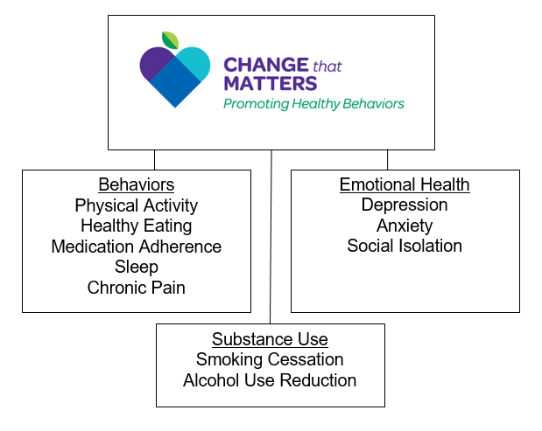

Each of the ten modules contains four components, namely an interactive patient handout, a didactic lecture, a demonstration video, and two templates for the Electronic Health Record (EHR) including (a) a brief set of prompts to guide the physician in the assessment and intervention during the patient visits and (b) a brief, bulleted text for the patient’s After Visit Summary (AVS).

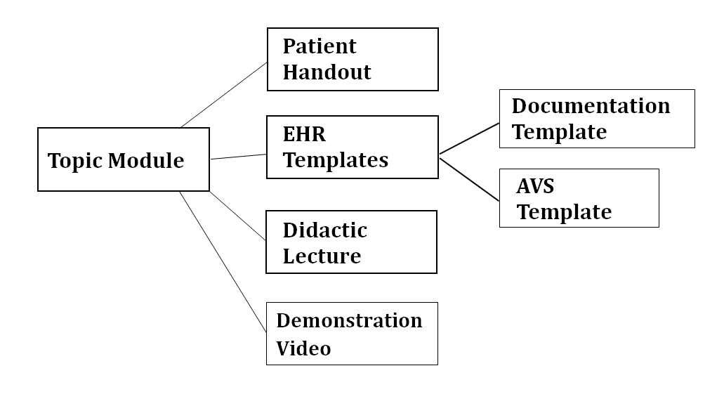

Patient Handouts: Colorful, interactive patient handouts invite patients to (1) identify their values or motivation for making the behavior change; (2) identify and problem solve barriers; and (3) set specific goals for change. The interventions in the handouts draw primarily from two theoretical frameworks, namely the Social Cognitive Theory (SCT)²⁶ and the Transtheoretical Model (TTM).²⁷ SCT suggests that supporting self-efficacy (the belief that one can perform the behavior), increasing knowledge of the risks and benefits of the behavior, defining goals, setting up supports, and decreasing barriers collectively increase the likelihood the target behavior will be performed. The TTM is a stage-based theory of how people change behavior, ranging from precontemplation (not considering a change at all) to maintenance (maintaining a new health behavior); motivational interviewing techniques²⁸ are person-centered directive strategies to help people progress along the stages. Thus, these brief interventions have a foundation in well-grounded theory that helps to explain how and why people make positive changes in their behavior.

EHR Templates: Two EHR templates exist for each module including:
- Brief assessment questions and intervention guidance for delivering the materials. This is to be used by the physician in the room with the patient.
- After Visit Summary (AVS) text, including the patient’s specific goal and general tips for the behavior change.

Didactic Lectures: Each module has a PowerPoint lecture slide set to prepare the physicians to do the assessment and deliver the intervention. Lecture length can vary depending on your available time and educational structure, but should be at least 45 minutes per lecture (generally we’ve found 60-90 minutes is a good length). All lectures follow this outline:
  - Brief Overview of the Scope of the Issue
  - Assessment Strategies
  - Evidence-based Treatments
  - Change That Matters’ Focus on Values/Meaning in Life
  - Tools for Addressing in Primary Care
    - Patient Handout
    - EHR Template
  - Structured Practice / Role-play **
  - Responding to Common Challenges in Helping Patients with this Issue
  - Resources for Further Learning

** An essential component of each didactic lecture is provider role-play of the materials. Guidance for how to set up and debrief after the practice is provided in each PowerPoint slide set.

Demonstration Videos: Each module has a 4-7 minute video portraying an example of how to deliver the intervention. The video consists of a conversation between a patient and physician about the target behavior, and effective ways of incorporating the patient handout in the discussion are demonstrated.

Implementation Steps

- Seek support from clinic leadership, including both administrative leaders (e.g., medical director) and educational leaders (e.g., program director/assistant program director). It is essential that medical faculty support the use of these behavioral interventions and encourage residents to use the provided tools.

- Identify site champions. Engaging an interdisciplinary core team of faculty to implement the curriculum is essential for success. Ideally, a behavioral health faculty member is the overall point person, coordinating all of the didactics. The behavioral health provider typically presents or co-presents most didactic sessions, especially those focused on mental health concerns (e.g., sleep, depression, stress). Drawing upon the expertise of interdisciplinary faculty members to present or co-present many of the didactics is maximally effective, such as:

  - Dietitian - Healthy Eating
  - Pharmacist – Medication Adherence
  - Addiction medicine faculty specialist or Alcohol/drug counselor - Alcohol Use
  - Community health worker - Social Connection
  - Sports medicine faculty – Physical Activity

Residents appreciate didactic sessions that include a multidisciplinary team of presenters.

Physician faculty also lend their expertise in tailoring the smart phrases to the specific EPIC program, and encouraging residents to use the curricular elements during precepting.

- Create a didactic training schedule that fits with the structure of your program. Implementing a new curriculum in busy training programs takes time and energy. Successful implementation requires investment from faculty, leadership, and residents.

Simple provision of the handouts and EHR templates will not prepare providers sufficiently to deliver the intervention effectively. It is essential that the providers participate in dedicated training to learn about the 10 topics and corresponding interventions and have the opportunity to practice using the curriculum. Although the curricular materials may appear straightforward and able to be implemented without training, doing so would limit the impact and likelihood of successful uptake. Therefore, an investment in training will have long-term benefits for providers and patients alike.

Furthermore, the curriculum contains a large amount of information, so spreading the delivery and implementation out over time is preferred. In our original development, we took 60-90 minutes of our behavioral health didactic session every month to teach residents about each topic; this gradual introduction helped them focus on each topic and have a chance to practice the skills shortly after the lecture.

Due to the very nature of busy, complex resident schedules, some repetition of didactic content is important. Residents may miss didactic lectures (e.g., being on away rotations, vacation, post-call), and desire the information and resources. Programs may explore creative ways of providing the information, such as (1) making the curricular elements (PowerPoint slides, handouts, smart phrases) publicly available such as on a program’s intranet site, (2) video recording the didactic sessions and sharing with residents, and (3) reviewing the availability of the curricular resources at regular staff and resident meetings.

Furthermore, each didactic session should include a brief review of the previously-taught content and resources. If time allows, dedicating a few minutes at the beginning of end of didactics for residents to role-play a physician-patient interaction about a topic recently taught can be helpful, both to reinforce learning and summarize the key points to residents who missed the didactic session.

- Create shared templates in your EHR for all providers to be able to access, both the in-visit note and the AVS text.

- Stock patient handouts in exam rooms and in resident work areas.

- Regularly encourage providers to use the curriculum. Oftentimes introduction of the curriculum via didactic sessions and attractive pamphlets in the exam rooms generates interest and investment in the program. However, for ongoing up-take of the curriculum, regular discussions and reminders for all clinic staff and residents are essential. Physician and behavioral health faculty can encourage residents to use the pamphlets during precepting, interdisciplinary team meetings, and complex care patient meetings. The curriculum should be introduced to new interns during orientation or shortly thereafter each year.

Expenses

- Reproduction of the patient handouts (we recommend color printing if possible)
- Handout holders for the exam rooms
- Reproduction of the posters for the exam rooms (and frames)

Tips for Working with Patients on Health Behavior Change

Helping patients make behavior change is difficult; providers and patients both can become frustrated and discouraged. The following tips can help providers who are starting to use these strategies:
- Take a long-term perspective (marathon not a sprint!)
- Focus on small changes.
- Remember that even small changes can have a big impact -- physically, emotionally, socially, etc.
- Maintain a spirit of hope!
- Remember that most patients WANT you to talk about these topics!
- These health behavior change topics are generally ongoing discussions. Strive to continue the conversations across visits by asking about tracking and celebrating small changes.
- All ten of our modules encourage patients to reflect on their values when making positive changes in their behavior. Research suggests that individuals who connect with their values and sense of meaning may be more likely to engage in healthy behavior;²⁹⁻³¹ thus, we encourage providers to help patients find a deeper reason why they want to engage in healthy behaviors as a way to enhance motivation for making a difficult change.

Special Thanks

Jen Brower, graphic designer of patient handouts

Andy Frye, art director and videographer for demonstration videos

Expert Reviewers who provided valuable feedback on our patient handouts:

Claudia Allen, JD PhD ABPP
Kate Brown, MD
Molly Clark, PhD
Kathryn Fraser, PhD
Thomas Hahn, MD
Ronni Hayon, MD
Marchion Hinton, PhD
Deirdre Paulson, PhD
Deanna Plant, MD
Lisa Prusak, MD
Erin Westfall, DO

Consultation

Drs. Hooker and Sherman are available for brief consultation on Change that Matters, and can be best reached via email:
Stephanie Hooker: stephanie.a.hooker@healthpartners.com
Michelle Sherman: MichelleDSherman2@gmail.com

References

1. National Center for Health Statistics. Table 19. Leading causes of death and numbers of deaths, by sex, race, and Hispanic origin: United States, 1980 and 2016. Health, United States, 2015: With Special Feature on Racial and Ethnic Health Disparities. Hyattsville, MD2016:107-110.
2. Gerteis J, Izrael D, Deitz D, et al. Multiple chronic conditions chartbook. AHRQ Publications No, Q14-0038. Rockville, MD: Agencry for Healthcare Research and Quality; 2014.
3. U. S. Burden of Disease Collaborators, Mokdad AH, Ballestros K, et al. The State of US Health, 1990-2016: Burden of Diseases, Injuries, and Risk Factors Among US States. JAMA. 2018;319(14):1444-1472.
4. Centers for Disease Control and Prevention (CDC). Nutrition, physical activity, and obesity: Data, trends, and maps. https://www.cdc.gov/nccdphp/dnpao/data-trends-maps/index.html. Accessed Jan 21, 2020.
5. Jamal A, Homa DM, O'Connor E, et al. Current cigarette smoking among adults - United States, 2005-2014. MMWR Morb Mortal Wkly Rep. 2015;64(44):1233-1240.
6. Ogden CL, Carroll MD, Fryar CD, Flegal KM. Prevalence of Obesity Among Adults and Youth: United States, 2011-2014. NCHS Data Brief. 2015(219):1-8.
7. Tucker JM, Welk GJ, Beyler NK. Physical activity in U.S.: adults compliance with the Physical Activity Guidelines for Americans. Am J Prev Med. 2011;40(4):454-461.
8. Bully P, Sanchez A, Zabaleta-del-Olmo E, Pombo H, Grandes G. Evidence from interventions based on theoretical models for lifestyle modification (physical activity, diet, alcohol and tobacco use) in primary care settings: A systematic review. Prev Med. 2015;76 Suppl:S76-93.
9. Larzelere MM, Williams DE. Promoting smoking cessation. Am Fam Physician. 2012;85(6):591-598.
10. Hechanova RL, Wegler JL, Forest CP. Exercise: A vitally important prescription. JAAPA. 2017;30(4):17-22.
11. Pinto BM, Lynn H, Marcus BH, DePue J, Goldstein MG. Physician-based activity counseling: intervention effects on mediators of motivational readiness for physical activity. Ann Behav Med. 2001;23(1):2-10.
12. Bogner HR, Morales KH, de Vries HF, Cappola AR. Integrated management of type 2 diabetes mellitus and depression treatment to improve medication adherence: a randomized controlled trial. Ann Fam Med. 2012;10(1):15-22.
13. Stead LF, Bergson G, Lancaster T. Physician advice for smoking cessation. Cochrane Database Syst Rev. 2008(2):CD000165.
14. Jonas DE, Garbutt JC, Amick HR, et al. Behavioral counseling after screening for alcohol misuse in primary care: a systematic review and meta-analysis for the U.S. Preventive Services Task Force. Ann Intern Med. 2012;157(9):645-654.
15. Kringos DS, Boerma WG, Hutchinson A, van der Zee J, Groenewegen PP. The breadth of primary care: a systematic literature review of its core dimensions. BMC Health Serv Res. 2010;10:65.
16. Solberg LI, Boyle RG, Davidson G, Magnan SJ, Carlson CL. Patient satisfaction and discussion of smoking cessation during clinical visits. Mayo Clin Proc. 2001;76(2):138-143.
17. Funderburk JS, Shepardson RL, Wray J, et al. Behavioral medicine interventions for adult primary care settings: A review. Fam Syst Health. 2018;36(3):368-399.
18. Moyer VA, Preventive Services Task F. Screening and behavioral counseling interventions in primary care to reduce alcohol misuse: U.S. preventive services task force recommendation statement. Ann Intern Med. 2013;159(3):210-218.
19. Denny CH, Hungerford DW, McKnight-Eily LR, et al. Self-Reported Prevalence of Alcohol Screening Among U.S. Adults. Am J Prev Med. 2016;50(3):380-383.
20. Gutierrez JC, Terwiesch C, Pelak M, Pettit AR, Marcus SC. Characterizing Primary Care Visit Activities at Veterans Health Administration Clinics. J Healthc Manag. 2015;60(1):30-42.
21. Bartsch AL, Harter M, Niedrich J, Brutt AL, Buchholz A. A Systematic Literature Review of Self-Reported Smoking Cessation Counseling by Primary Care Physicians. PLoS One. 2016;11(12):e0168482.
22. Keto J, Jokelainen J, Timonen M, Linden K, Ylisaukko-oja T. Physicians discuss the risks of smoking with their patients, but seldom offer practical cessation support. Subst Abuse Treat Prev Policy. 2015;10:43.
23. Sherman MD, Hooker SA. Family medicine physicians’ confidence and perceived effectiveness in delivering health behavior change interventions. Fam Pract. in press.
24. Guo H, Pavek M, Loth K. Management of Childhood Obesity and Overweight in Primary Care Visits: Gaps Between Recommended Care and Typical Practice. Current Nutrition Reports. 2017;6(4):307-314.
25. PEMAT for Printable Materials (PEMAT-P). Content last reviewed. https://www.ahrq.gov/ncepcr/tools/self-mgmt/pemat-p.html. Accessed Jan 21, 2020.
26. Bandura A. Social cognitive theory of self-regulation. Organizational Behavior and Human Decision Processes. 1991;50(2):248-287.
27. Prochaska JO, DiClemente CC. Stages and processes of self-change of smoking: toward an integrative model of change. J Consult Clin Psychol. 1983;51(3):390-395.
28. Miller WR, Rollnick S. Motivational Interviewing: Helping People Change. Third ed. New York: Guilford Press; 2012.
29. Hooker SA, Masters KS. Daily meaning salience and physical activity in previously inactive exercise initiates. Health Psychology. 2018;37(4):344-354.
30. Hooker SA, Masters KS. Purpose in life is associated with physical activity measured by accelerometer. Journal of Health Psychology. 2016;21(6):962-971.
31. Hooker SA, Masters KS, Park CL. A meaningful life is a healthy life: A conceptual model linking meaning and meaning salience to health. Review of General Psychology. 2018;22(1):11-24.

